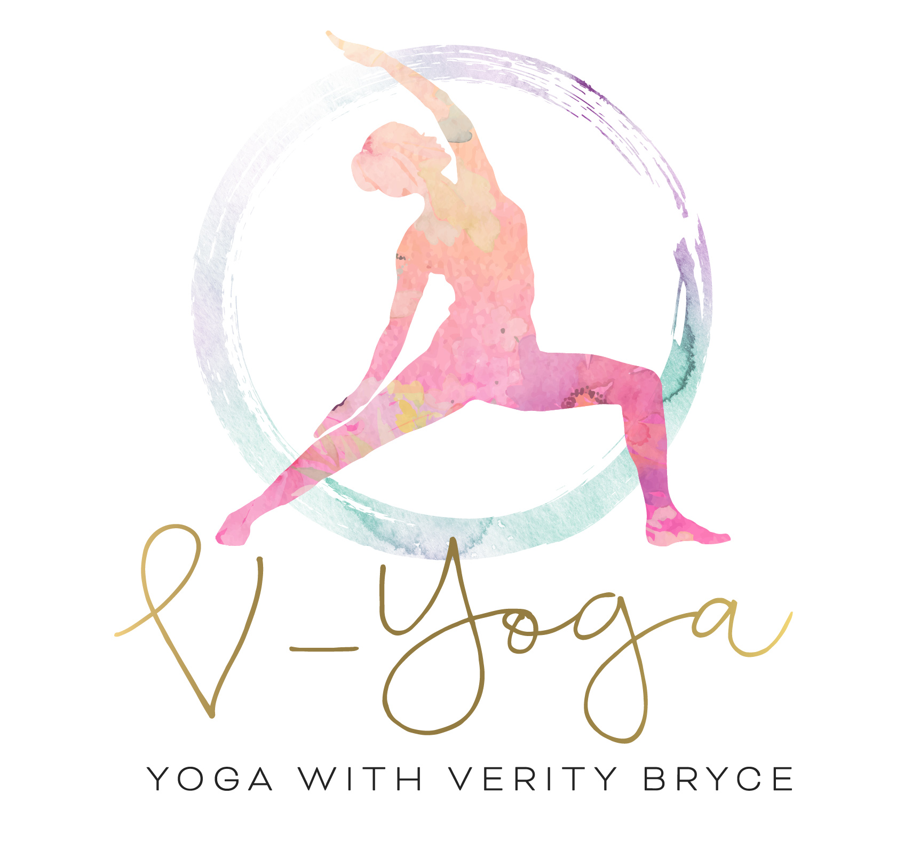
Facebook Live Classes

Wednesday
Beginners Class
6pm - 7pm

Thursday
Hatha Yoga
6pm – 7pm

Saturday
Vinyasa
10am – 11am

